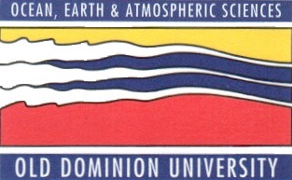

SPRING 2013 SEMINAR SERIES
DEPARTMENT OF OCEAN, EARTH, AND ATMOSPHERIC SCIENCES
3PM – ROOM 200 IN THE OCEANOGRAPHY/PHYSICS BUILDING
THURSDAY FEBRUARY 14th, 2013

“Geology and Public Policy – Recent Issues in Virginia.”

David Spears
Virginia Department of Mines, Minerals and Energy

ABSTRACT
Government decision makers are faced with difficult choices when it comes to public policy regarding energy and mineral resources. Our nation is heavily dependent on fossil fuels, fissile materials, rare earth elements and other raw materials which often come from foreign sources. Even though developing our own domestic supplies has obvious strategic advantages, such development often conflicts with other societal priorities such as environmental protection and social justice. To further complicate matters, pressure is brought to bear on politicians by an uninformed or misinformed populace that is generally anti-development and by businesses that have a financial interest in development. In this presentation, Virginia’s State Geologist will use recent, Virginia-specific examples such as uranium mining, shale gas, and offshore drilling to highlight the ways in which government-based geoscientists play a unique role in providing unbiased scientific guidance in public debates about how to best manage our nation’s energy and mineral resources.

After the seminar, please join us in room 404, the Zaneveld Conference Room, for coffee and cookies, and to meet with the seminar speaker.

