**General Education Assessment**

**2022-2023 Results for Oral Communication**

**Executive Summary**

In July 2023, faculty rated 211 speeches to determine the extent to which students were achieving the specified outcomes for general education in 100-level oral communication courses. The outcome with the highest average rating was *analyzing and adapting communication styles to diverse audiences and contexts* (SLO B). The outcome with the lowest average rating was *preparing, researching, and organizing the content of a message for a specific audience* (SLO C).

A description of the methodology results and recommendations can be found in the full report below. Other information, such as the rubric, can be found on the Office of Institutional Effectiveness & Assessment’s website:

**Oral Communication Assessment Report**

As part of Old Dominion University’s general education requirement, students must complete the oral communication requirement. The lower division oral communication skills are taught in the Communication 100-level composition courses (COMM 101R). The student learning outcomes approved by Faculty Senate for COMM 101R include:

1. Relate the principles of oral communication to a variety of interpersonal, professional, and extemporaneous situations.
2. Analyze and adapt communication styles to diverse audiences and contexts.
3. Prepare, research, and organize the content of a message for a specific audience.
4. Use effective verbal and non-verbal language in conveying a message.
5. Apply listening skills to provide a critical analysis of interpersonal and professional messages.

**Methodology**

The coordinator for the oral communication general education courses determined that the ten competencies on the common [rubric](https://olddominion.sharepoint.com/:w:/r/sites/GeneralEducationReviewDocuments/Shared%20Documents/General/Assessment/Oral%20Communication/2022-23/COMM%20101%20Rubric%2022-23.docx?d=w48de0301acc14091a12d9681354a563f&csf=1&web=1&e=yBbSFj) used by instructors mostly aligned with the student learning outcomes (SLO). The rubric was adapted from the National Communication Association (NCA). The NCA competencies were modified to add two additional competencies: speaking (not reading) from an outline and sufficiently developing a speech within time guidelines. Before the session, the Office of Institutional Effectiveness & Assessment worked with the course coordinator for COMM 101R. Outcome E did not align with the rubric and was assessed through surveys this cycle. The ten rubric competencies were [mapped](https://public.tableau.com/views/OralCommunicationGeneralEducationSummitResults2023/SLOMap?:language=en-US&:display_count=n&:origin=viz_share_link) to outcomes A-D.

In past assessment cycles, raters were sent into the classroom to rate speeches. This cycle, we focused on assessing online courses since they were never included in the assessment process. 31% of Oral Communication 101R students took the course online in Fall 2022 and Spring 2023. Because online courses had speeches that could be downloaded, this also allowed us to increase our sample size and include more faculty in the assessment process as raters. The group of raters was made up of a combination of online and face-to-face instructors. In the debrief discussion, raters noted that the results were similar to what they notice teaching face-to-face courses.

A calibration session was conducted with eight raters who teach COMM 101R and were accustomed to using the rubric to score speeches. First, faculty thoroughly reviewed and discussed the rubric. Then, they practiced rating three shared speeches. Raters shared their ratings and discussed any differences after each round of rating. This discussion helped faculty come to a common understanding of what the student learning outcomes (SLO) meant and what to look for when rating the speeches using the rubric’s scale: unsatisfactory, fair, satisfactory, and excellent. Once individual ratings on a shared speech did not differ by more than one point, raters began rating their assigned speeches.

Of the 211 artifacts that were rated, 45 of them (20%) were read twice for the establishment of inter-rater reliability. Of the artifacts rated twice, 45% were exact matches, 45% were off by 1 point, and 11% were off by 2 points. No artifacts required 3rd reviews.

**Results - Achievement of Standard**

The outcome that received the highest percentage of students who achieved or exceeded the standard was B: *analyze and adapt communication styles to diverse audiences and contexts* (SLO B: 72% of students rated at or above standard). SLO B also had the highest average rating of 3.02.

The outcome that received the lowest percentage of students achieving the standard was C: *use effective verbal and non-verbal language in conveying a message* (SLO C: 54% at or above standard). SLO C had the lowest average rating at 2.59.

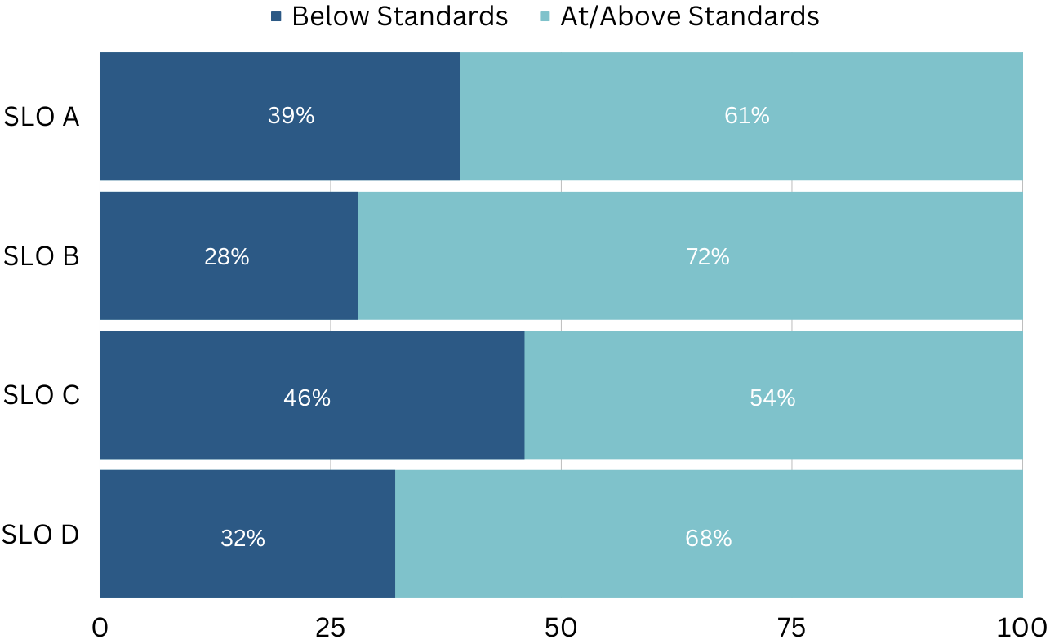

**Table 1: Oral Communication Assessment Results, Achievement of Standard**

Detailed results can be viewed [here](https://public.tableau.com/views/OralCommunicationGeneralEducationSummitResults2023/ArtifactsRatingDistribution?:language=en-US&publish=yes&:display_count=n&:origin=viz_share_link).

**Listening Skills (SLO E)**

In a survey sent to Oral Communication 101R instructors with 15 respondents, 14 respondents said that students had at least one listening assignment. 10 respondents indicated that students completed two or more assignments with listening assignments.

When asked to describe the majority of students’ ability to apply listening skills by the end of the course, 10 respondents said students are able to critically analyze spoken messages carefully and thoughtfully, while 5 respondents said students are able to listen to comprehend information but cannot analyze messages. No respondents answered that students struggle to listen, leading to inaccurate interpretations.

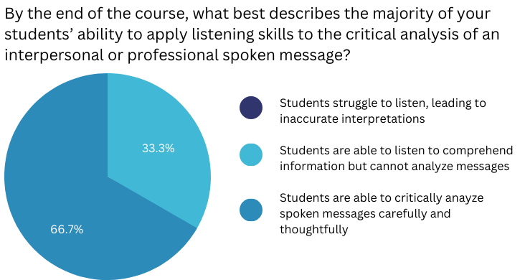

**Table 2: Instructor ratings of student listening skills at the end of the course**

**Senior Student Satisfaction Survey**

In the Senior Student Satisfaction Survey, Fall 2022 and Spring 2023 graduating students were asked to rate their own interpersonal communication skills and oral communication skills. 70% of the 3,547 respondents rated themselves as either above average or in the top 10% compared to the average person their age at interpersonal communication. 66% of respondents rated themselves as either above average or in the top 10% compared to the average person their age at oral communication.

Of Spring 2023 graduates, 92% of 952 respondents agreed or strongly agreed that their ODU General Education courses developed their ability to effectively communicate verbal messages in a variety of contexts.

**Discussion**

The raters noted that students strengths using language appropriate to the audience and occasion (mapped to SLO B) and using vocal variety and appropriate pronunciation, grammar, and articulation (mapped to SLO D). They noticed weaknesses were eye contact and reading from the outline, which was mapped to SLO D but could also affect other outcomes.

The rubric competencies have areas of overlap where some skills are being rated in overlapping areas. The rubric does not align with the Student Learning Outcomes but there are areas of overlap. Raters discussed streamlining the rubric; one rater brought up adding detail and combining categories on the rubric.

Instructors noted that they did not notice significant differences between face-to-face and online students. Students’ struggles seem the same across modalities. Instructors also noted the assessment process helped them reevaluate themselves as instructors and reflect on their teaching.

**Recommendations**

The rubric and/or the Student Learning Outcomes need to be revised so they are more clearly aligned. For the next assessment cycle, collect assignments from online and in-person courses and collect listening assignments. At the General Education Assessment Committee meeting, it was recommended that other courses that fulfill the requirement, such as DANC 152R, THEA 152R, and courses within specific majors be included in the next assessment cycle.

**Plan to Improve Learning**

The Communications Department will develop a plan to improve based on the results and recommendations.

**Faculty Senate Recommendations**

TBD