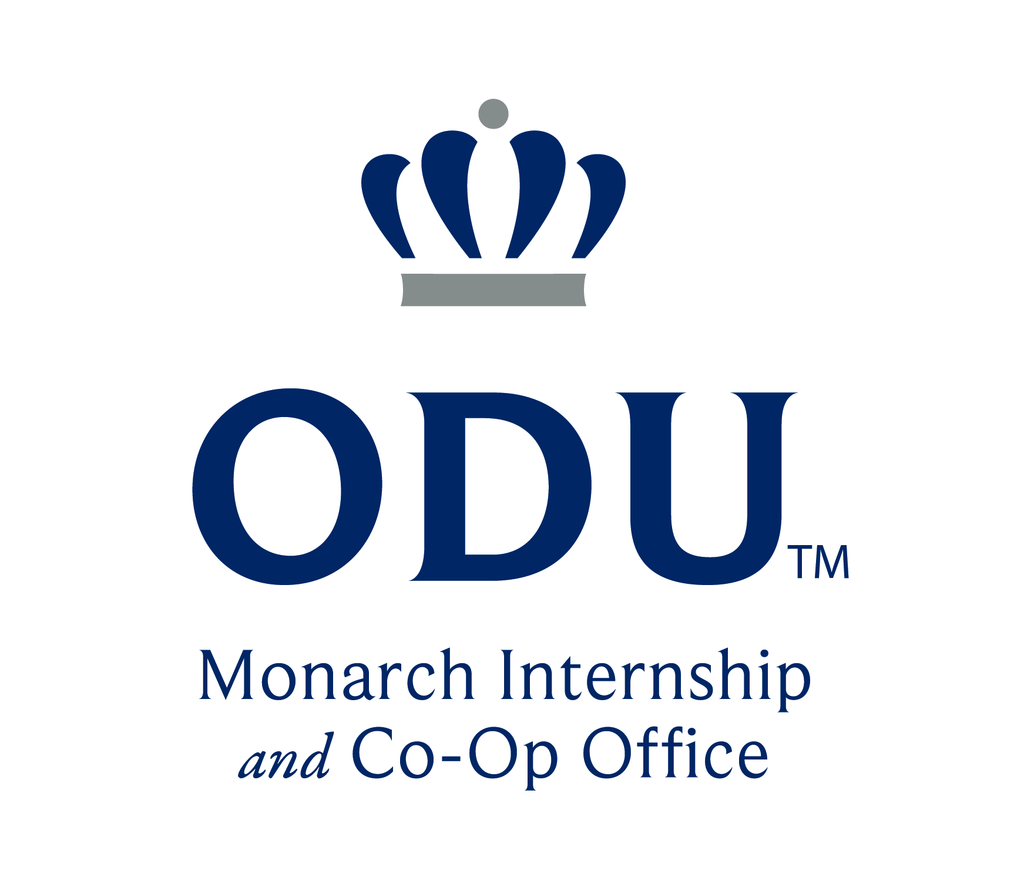
🌎 International Students, Internships & Curricular Practical Training (CPT)

What is CPT?
-Curricular Practical Training (CPT) allows F-1 international students to gain professional experience as part of their academic program.
-CPT is treated as a course with registration (as part of a student’s curriculum)
-Students must follow all rules set by ODU’s Visa & Immigration Service Advising (VISA) Office.

MICO’s Role
-The Monarch Internship & Co-Op (MICO) Office reviews CPT requests when the internship is not tied to academic credit.
- Students enroll in MICO-administered courses for transcript recognition, when academic departments do not have internship elective courses of their own; these are 0-credit courses.
- If the internship is tied to a credit-bearing course, the faculty of record completes CPT paperwork--no MICO Office approval is needed.

Faculty – What You Need to Know
- CPT always requires course registration.
- Internship offer letters must include a future start date (at least 10 business days after submission).
- If the internship offer is received after the Add/Drop date for a credit bearing course, the student should work with their academic department (for departmental internship credit) or the MICO office (for the 0-credit internship course) to register via an Add/Drop/Withdraw form from the Registrar’s Office.

Key Steps for Students
1. Attend a CPT workshop (required – can be in-person or virtual pre-recorded video).
2. Secure an offer letter from an employer which specifies the hours worked, the pay, description of duties, work location, name of company/entity hiring the student, and supervisor information.
3. Submit CPT request + offer letter to MICO for 0-credit or Faculty of Record for departmental internship/practicum coursework for signature. Upon completion, form and offer letter should be uploaded to the CPT Request submission on the International Student Portal. CPT requests are reviewed in order of submission. Students should submit CPT requests as soon as an internship offer is received to ensure processing prior to start date.
4. Allow 10 business days for processing. Students must wait until their CPT I-20 is received to begin work.
Quick Reminders
- Part-time CPT = ≤20 hrs/week
- Full-time CPT = 21+ hrs/week (only an option in summer, final semester, or dissertation stage of program (Doctoral students only).
- GPA: 2.0+ undergrad / 3.0+ grad
- Must have completed 2 full-time enrolled semesters (can be from different visa status and/or degree program) before applying (unless earlier internship/practicum is required by academic department).
Student partaking in greater than 364 days of full-time CPT will void their eligibility for OPT.

Questions? Contact the Monarch Internship & Co-Op Office: 1007 Webb Center, internship@odu.edu 757-683-JOBS OR ODU VISA at 2006 Dragas Hall, intlstu@odu.edu, 757-683-4756
🌐 ODU VISA CPT Guidelines: https://www.odu.edu/visa/employment/employment-international-students

