
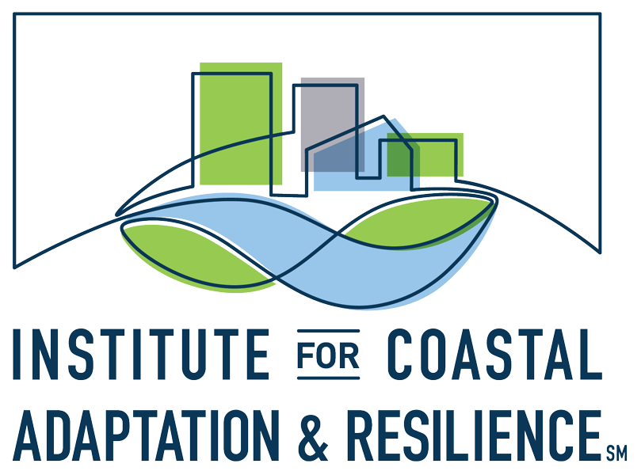

Spring 2026 Virtual Seminar Series

ALYSSA BUCCI, ELLA DIPETTO,
& ZLATKA REBOLLEDO SANCHEZ
Virginia Sea Grant Graduate Research Fellows, Old Dominion University

Monday, March 30, 2026
3:30 PM EST

ZOOM LINK
Meeting ID: 972 4903 1602
Passcode: 410944

Water Quality Impacts of Tidal Flooding: Variability in Nutrient and
Fecal Bacteria Concentrations across Watersheds with Different Land Uses
ALYSSA BUCCI

Abstract
Tidal flooding is an increasingly pressing hazard in low-lying coastal areas worldwide. The Hampton Roads region of Virginia has the second-highest rate of relative sea level rise in the United States and experiences frequent tidal flooding, but the water quality impacts of this flooding on the Chesapeake Bay are not being accounted for. High concentrations of nutrients and Enterococcus bacteria (a fecal indicator) have been observed in tidal floodwaters in this region. Research has demonstrated that the entire annual nitrogen load allocation for the Lafayette River, a sub-tributary of the Chesapeake Bay, can be delivered in a single “king tide” flood. This study investigates variability in nutrient and Enterococcus concentrations in tidal floodwater across different watersheds, land uses, and flooding routes within Hampton Roads. Floodwaters in urban and rural watersheds were sampled through community science events in multiple floods over three years. Floodwater concentrations of nutrients and Enterococcus consistently exceeded baseline conditions, and there was high variability in concentrations of both parameters. Enterococcus concentrations frequently exceeded the recreational safe contact limit. This research demonstrates that tidal flooding can impact water quality and public health in coastal areas like the Chesapeake Bay. These impacts must be considered in restoration planning and climate change response.

Biography
Alyssa Bucci is an Ocean & Earth Sciences master’s student at Old Dominion University and a Virginia Sea Grant Graduate Fellow. Before graduate school, she worked as an environmental scientist for a state water quality agency promoting best practices in agriculture. She is interested in anthropogenic impacts on water quality in coastal environments. Her research analyzes the impact of land use on nutrient and bacteria loading to the Chesapeake Bay during tidal flooding. She utilized community science to collect water quality data and promote community involvement.

Working towards future-oriented coastal protection:
The utility of living shorelines under changing climatic conditions
ELLA DIPETTO

Abstract
Living shorelines, nature-based approaches to coastal protection, are increasingly used as sustainable alternatives to traditional shoreline armoring. While these approaches stabilize shorelines and enhance ecosystem functioning, their long-term effectiveness is uncertain as climate change drives sea-level rise, intensifying storms, and shifting ecological conditions. This seminar highlights findings from my recent published review examining how climate change may influence the stability and function of living shorelines and natural coastal ecosystems. I will discuss the future role of living shorelines within coastal adaptation and introduce key principles to improve their long-term sustainability. This work emphasizes the importance of preparing living shorelines for the dynamic coastal environments of the future.

Biography
Ella DiPetto is a fifth year PhD Candidate in Dr. Eric L. Walters’ Community Ecology Lab at ODU, having received her bachelor’s degree in Wildlife Conservation from Virginia Tech in 2018. She was then involved in a variety of projects encompassing avian research, coastal restoration, and environmental education. Her graduate research focuses on living shorelines, a form of nature-based shoreline protection. Ella is interested in both ecological and social considerations of living shorelines, particularly along developed coastlines and residential properties, and works to better understand the valuable ecosystem services that living shorelines provide.

Carbon and vegetation spatial variability in Virginia salt marshes
ZLATKA REBOLLEDO SANCHEZ

Abstract
A spatially explicit approach is needed to estimate carbon and vegetation metrics in marshes to reach conservation goals. However, most blue carbon studies rely on limited sampling from core portions of marsh patches, as well as on location, regional, or national averages, often without considering spatial variability. In our research, we observed spatial heterogeneity at various spatial scales, implying differences across sites, between, and within multiple sites in the lower Chesapeake Bay. To better understand this variability, we performed an intra-patch analysis focused on salt marsh-tidal flat transition zones. This involved establishing transects across these ecotones and examining aboveground vegetation, roots, and sediment cores. Preliminary results indicate differences in all metrics between marsh interior, marsh edge, and tidal flats, with edges displaying greater variability in plant-based metrics. It was also found higher aboveground biomass closer to the edge and higher soil carbon values in the interior areas of the patch. By incorporating this spatial framework, the applicability of blue carbon initiatives can be broadened, mitigation strategies can be better informed, and planning for future scenarios can be more robustly supported. Ultimately, our study emphasizes the need for a finer spatially explicit approach to estimating carbon and vegetation in marshes, as this will support more realistic management and conservation strategies.

Biography
Zlatka Rebolledo Sanchez is a biologist from Simón Bolívar University, Caracas, Venezuela and is currently an Ecological Sciences Ph.D. student at Old Dominion University. She is a member of the Coastal Plant and Ecotone Ecology Lab, studying marine and coastal ecosystems with a spatial ecology perspective. Zlatka is a 2023–2025 Virginia Sea Grant Graduate Research Fellow and a Rising TIDES Scholar of the Coastal and Estuarine Research Federation.

https://www.odu.edu/coastal-physical-oceanography/seminar-series

