


Welcome to THRIVE @ ODU, the Division of Talent Management and Culture’s new quarterly newsletter. Our goal is to keep you informed and engaged with the latest updates on faculty and staﬀ news, important reminders, policy changes, beneﬁts, and special opportunities. Each issue will highlight resources and programs to help you succeed and thrive as part of the Monarch community.

Reminder: Classiﬁed Employee Performance Evaluation Cycle
As we continue to enhance our performance review process. This notice serves as a reminder that Old Dominion University has adopted the Performance Cycle that the Commonwealth of Virginia uses. Unless otherwise approved by the Department of Human Resource Management (DHRM), the Commonwealth’s standard performance cycle runs January 1 through December 31. Evaluations for non-probationary classiﬁed employees will be due February 1, 2026. Additional communications and guidance will be shared in the coming months to support you with this new process.
You're encouraged to review the DHRM Policy #1.40 - Performance Management (revised August, 22, 2025) which provides detailed guidance on performance planning, interim reviews, and annual

evaluations.
We encourage you to address supervisor/reporting changes now so you are ready to review without issues.
Employees will be provided one of ﬁve performance ratings on both Interim and Annual Performance Evaluations for each performance objective and competency resulting in an overall rating of:

- Unsuccessful – the employee did not meet the expectations of the performance objective and competency.
- Partially Successful – the employee occasionally met the expectations of the performance objective and competency but was not consistent and at times did not meet the expectations.
- Successful – the employee consistently met the expectations of the performance objective and competency.
- Highly Successful – the employee exceeded the expectations of the performance objective and competency some of the time.
- Extraordinary – the employee consistently exceeded the expectations of the performance objective and competency

As a supervisor, it is vital to ensure that employees receive clear expectations, recognition for their contributions, and support for growth and development. Please ensure evaluations are completed thoroughly and submitted on time.
More details and resources will be shared in the coming months. Should you have any questions about this notiﬁcation, please email hrdept@odu.edu.

Title IX Responsible Employee (RE) Duties at ODU

Who is a Responsible Employee?
A Responsible Employee (RE) is someone who:

- Has authority to address sexual harassment (including sexual assault, dating violence, domestic violence, and stalking), or
- Is required by ODU policy to report it, or
- Is someone a student could reasonably believe has this authority or duty.

Who is required to report?
At ODU, Responsible Employees include:

- All teaching and research faculty
- Graduate teaching assistants and graduate research assistants
- Resident Assistants
- Law enforcement oﬃcers
- Campus Security Authorities (CSAs)
- Employees with supervisory duties
- Employees designated as REs by their supervisors

Conﬁdential Roles and Dual Roles

- Conﬁdential employees (e.g., licensed counselors, medical providers, health professionals) are exempt when acting within their professional/clinical role.

- Dual-role employees may sometimes act as conﬁdential providers and other times as Responsible Employees.
  - Example: A clinician providing mental health counseling is not required to report.
  - The same clinician, if serving as a faculty member or advisor outside of counseling duties, must report disclosures received in that capacity.

What must be reported?
All known details, including names, dates, and locations, and the nature of the incident.

How do I fulﬁll my responsibility?
Report to:

- Title IX Coordinator – Kate Couch (titleixcoordinator@odu.edu, 757-683-3141, online reporting form)
- Or a Deputy Title IX Coordinator (see full list below)

Why does reporting matter?
Your report ensures:

- The individual receives timely support and resources.
- ODU can take prompt action to stop and address misconduct.
- The University can prevent future incidents and maintain a safe, respectful environment.

Important reminders

- You cannot guarantee conﬁdentiality, but you can assure privacy on a need-to-know basis.
- Retaliation for reporting or fulﬁlling RE duties is prohibited.
- Do not investigate or resolve incidents yourself.
- Failure to report may result in corrective action.

Contact Information
Title IX Coordinator (campus-wide)
Ms. A. Kate Couch – titleixcoordinator@odu.edu | 757-683-3141

Deputy Title IX Coordinators
Dr. Evelyn Ashley – ODU Students | eashley@ odu.edu | 757-683-6702 Ms. Carolyn Crutchﬁeld – Athletes | cacooper@odu.edu | 757-683-4265 Dr. Shanda Jenkins – ODU Faculty | sjenkins@odu.edu | 757-683-4327
Mr. Matthew Schenk – Medical Campus Employees | mschenk@odu.edu | 757-446-6043 Dr. Melissa Scott – Medical Campus Students | scottmj@ odu.edu | 757-446-8927
More info: Title IX & Sexual Misconduct

September is National Workforce Development

Month
TMC celebrates National Workforce Development Month by recognizing the value of continuous learning and professional growth. ODU oﬀers a variety of resources to help you expand your skills, strengthen your career path, and achieve your goals.
This nationwide observance is dedicated to promoting a strong and skilled workforce. It highlights the importance of investing in employee training, education, and career advancement to meet evolving industry needs and help individuals reach their full potential. To support this initiative, the TMC division will be hosting a series of in-person and virtual workforce development workshops throughout the month. These workshops will be led by presenters who bring a wealth of knowledge and experience, oﬀering valuable insights to all attendees.
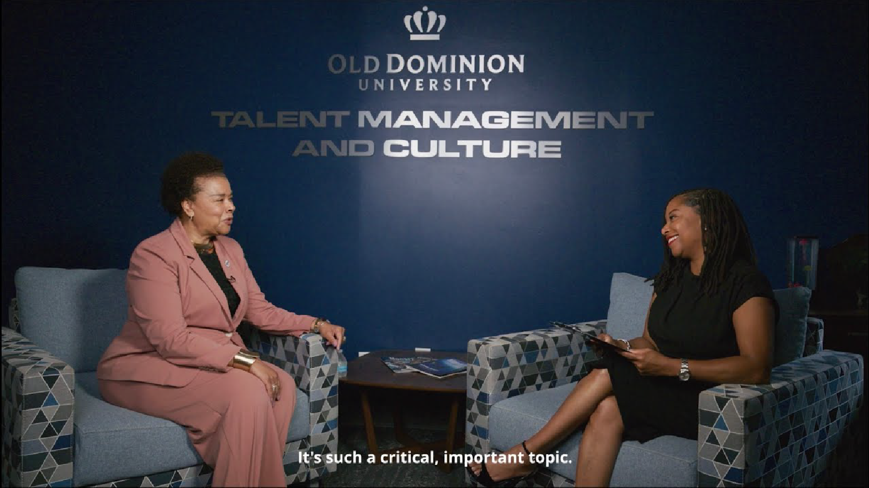

We invite you to enjoy this interview with Senior Associate Vice President and CHRO Kimberly Wilson and Director of Workforce Programs and Ombudsperson, Dr. Diane Holland.

Register for Sessions



ODU Football - Faculty & Staﬀ Discount
Our football Monarchs are rolling with a 2-1 start and a HUGE win over Virginia Tech—and we need your support to keep the momentum going! Next up is a big matchup at home against Liberty on Saturday, September 27th under the lights at S.B. Ballard Stadium.
This is the perfect chance to show our student-athletes that the ODU community is behind them, and we’re excited to make it even easier for you to join us with a exclusive tickets oﬀer for all ODU and VHS Faculty & Staﬀ members.

Faculty & Staﬀ Ticket Oﬀer
- Exclusive Rate – Savings from 33-43% oﬀ general public pricing!
- Flexible Options – Games and oﬀers will be added throughout the season.
Let’s pack the stands, bring the energy, and make September 27th a night to remember as we cheer on the Monarchs against Liberty!
Purchase Tickets




Anthem EAP Expansion
During those moments when you feel overwhelmed, your Employee Assistance Program (EAP) is here for you with real-life tips, tools, articles, webinars, and links to helpful resources. As always, your EAP is private, conﬁdential, and included as part of your beneﬁts. EAP is available to all Commonwealth of Virginia employees and household members or dependents, even if you're not enrolled in an Anthem medical Plan.
Employees and their household members are eligible for up to four free online or in-person counseling sessions per issue each year. In addition, other well-being resources can be accessed on the EAP website.
Employees can engage with EAP by visiting anthemeap.com/cova or calling 855-223-9277.

More Info: Anthem EAP

Transforming talent, elevating excellence.

Old Dominion University | Hampton Boulevard, Norfolk, VA 23529

Old Dominion University (ODU), located in Norfolk, is Virginia's forward-focused public doctoral research university with more
than 24,000 students. A top R1 research institution oﬀering rigorous academics, ODU is recognized nationally for academic excellence, social mobility and access. Military friendly and home to an energetic residential community and robust initiatives that currently contribute $3.8 billion annually to Virginia's economy, ODU is a leader in the commonwealth. Macon & Joan Brock Virginia Health Sciences at Old Dominion University, founded July 1, 2024, represents the most comprehensive health sciences center in the Commonwealth of Virginia.
© 2025 Old Dominion University. All Rights Reserved.

Manage your preferences | Opt Out using TrueRemove™ Got this as a forward? Sign up to receive our future emails. View this email online.

Hampton Blvd | Norfolk, VA 23529 US
This email was sent to .
To continue receiving our emails, add us to your address book.
Subscribe to our email list.

