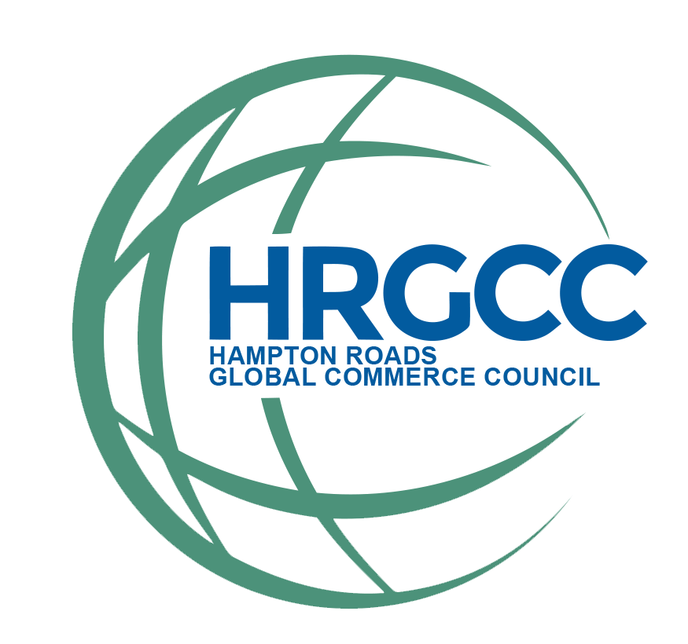
2026 HRGCC Supply Chain Scholarship
Scholarship Overview: The Hampton Roads Global Commerce Council (HRGCC) is committed to fostering the growth of national and international commerce throughout Hampton Roads. Our mission is to connect and support industries in the area that contribute to that growth, including air, rail, trucking, and sea transport sectors. In alignment with this mission, HRGCC is pleased to offer two scholarships of $2,500 each to college students pursuing education and careers in Supply Chain Management, Logistics, or Maritime Operations or related fields. These scholarships aim to recognize academic excellence and dedication to these essential industries and may be used for any educational expenses. Applications and supporting materials are due by March 17,2026. HRGCC will notify the scholarship recipients by April 1, 2026, and announce the winners at the Annual State of the Port Luncheon on April 23, 2026.

Eligibility Criteria: To qualify for the HRGCC scholarship, applicants must:
- Be a full-time student currently enrolled at a four-year university in the Hampton Roads, Virginia Area.
- Be pursuing a degree in Supply Chain Management, Logistics, Maritime Operations, or a closely related field.
- Maintain a minimum GPA of 3.0.
- Demonstrate a commitment to academic achievement and/or professional growth in the field.
- Submit a completed application by Tuesday, March 17, 2026.

Application Requirements: To apply, please submit the following materials:
- A completed application form (attached to this announcement).
- A one-page essay addressing the topic: What are your career goals in Supply Chain Management, Logistics, or Maritime Operations and how will this scholarship help you achieve them?
- A copy of your most recent transcript.
- One letter of recommendation from a professor, academic advisor, or industry professional familiar with your work and aspirations in the field.

APPLICATION FORM:
Personal Information:
Full Name: _______________________________ Date of Birth: _______________________
Address: ______________________City: _______________ State: ____ Zip Code: ________
Phone Number: _______________________ Email Address: ___________________________
Academic Information:
Current Institution: ___________ __ ___ Current GPA: _________________
Program of Study/Major: ____________ ____ Anticipated Graduation Date: _____________
Essay Submission: Please attach a separate document with your one-page essay (250 to 500 words).
Certification: By signing below, I certify that the information provided in this application is true and accurate to the best of my knowledge.
Signature: _______________________________
Date: _______ _____________

Submission Instructions: Completed applications and supporting documents must be submitted (received?) by Close of Business Tuesday, March 17, 2026 via one of the following methods:
- Email: info@hrgcc.org (Subject Line: Scholarship Application - [Your Full Name])
- Mail: P.O. Box 3301, Norfolk, VA 2314, Attn: Scholarship Committee

Selection Process: Scholarship recipients will be selected based on the quality of their application materials, including their essay, academic achievements, and demonstrated interest in Supply Chain, Logistics, and Maritime Operations. Winners will be notified by April 1, 2026.

For questions or additional information, please contact Jerry Cronin at jcronin@odu.edu or 757-876-1562. We look forward to reviewing your application!

